**Simplifying If Statements**



**The Ternary Operator**

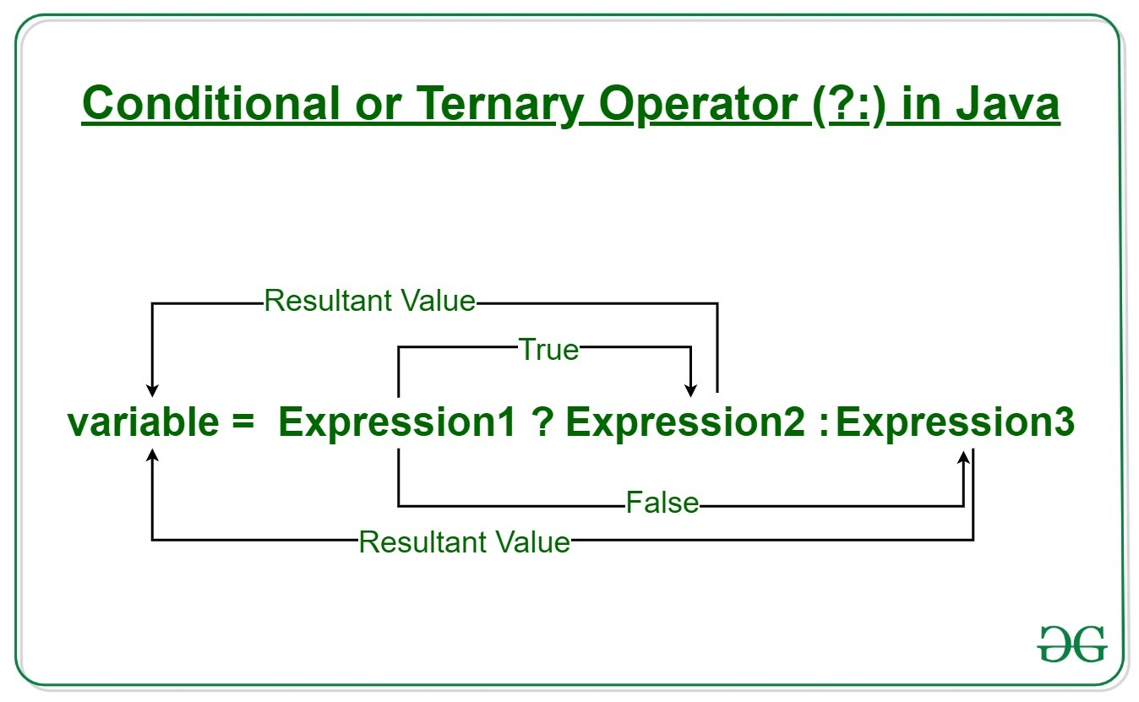

**Switch Statements**

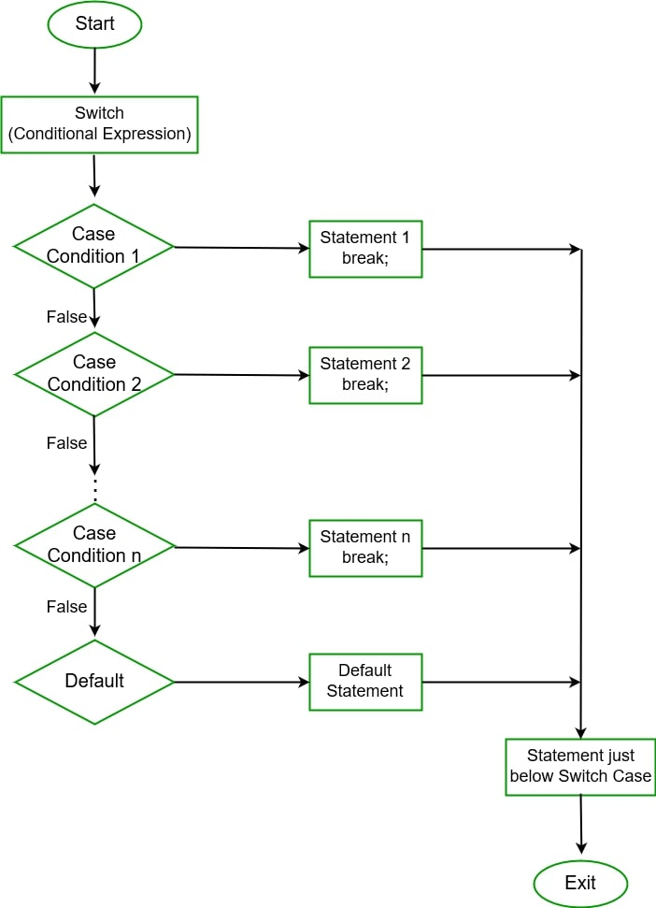

**For Loops**

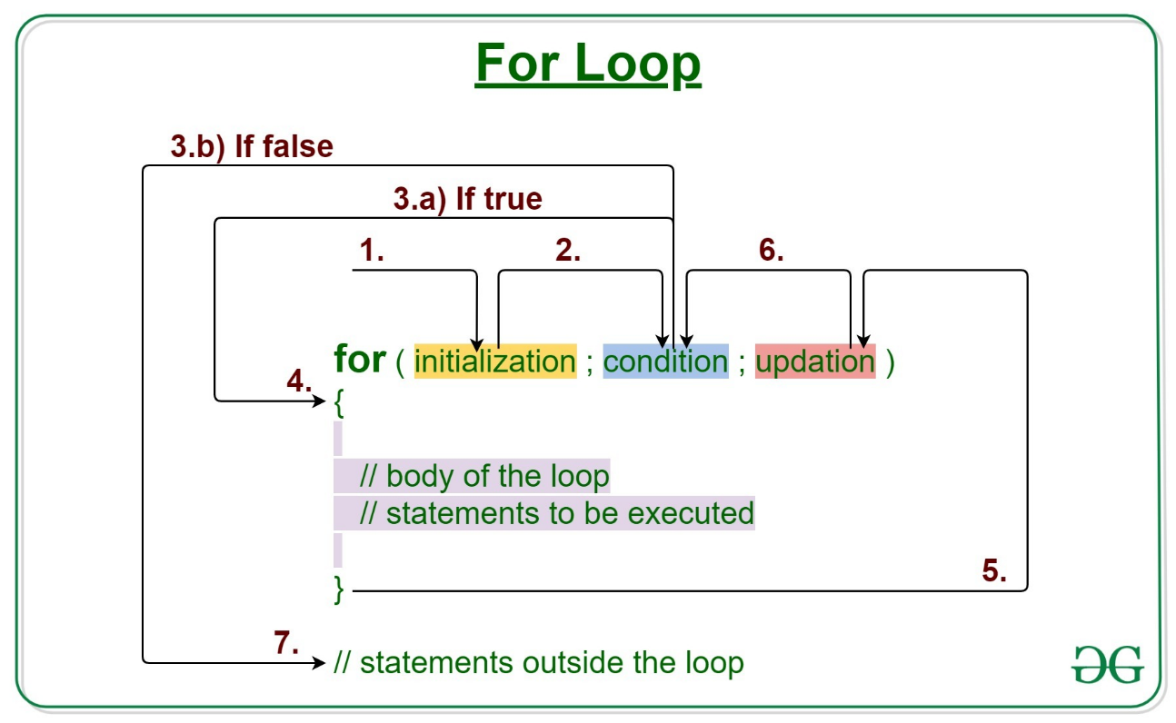

**While Loops**

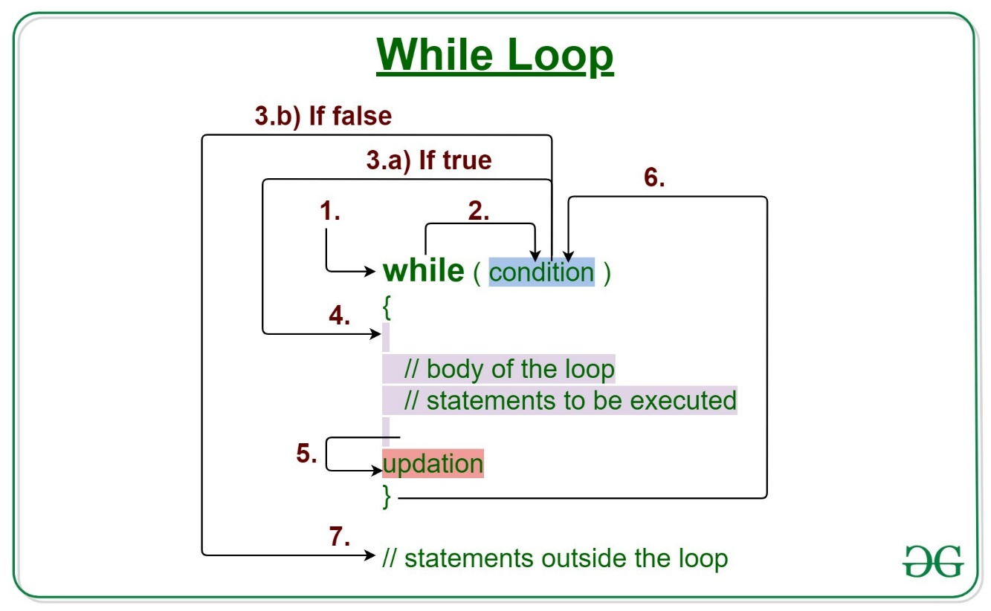

**Do-While Loops**

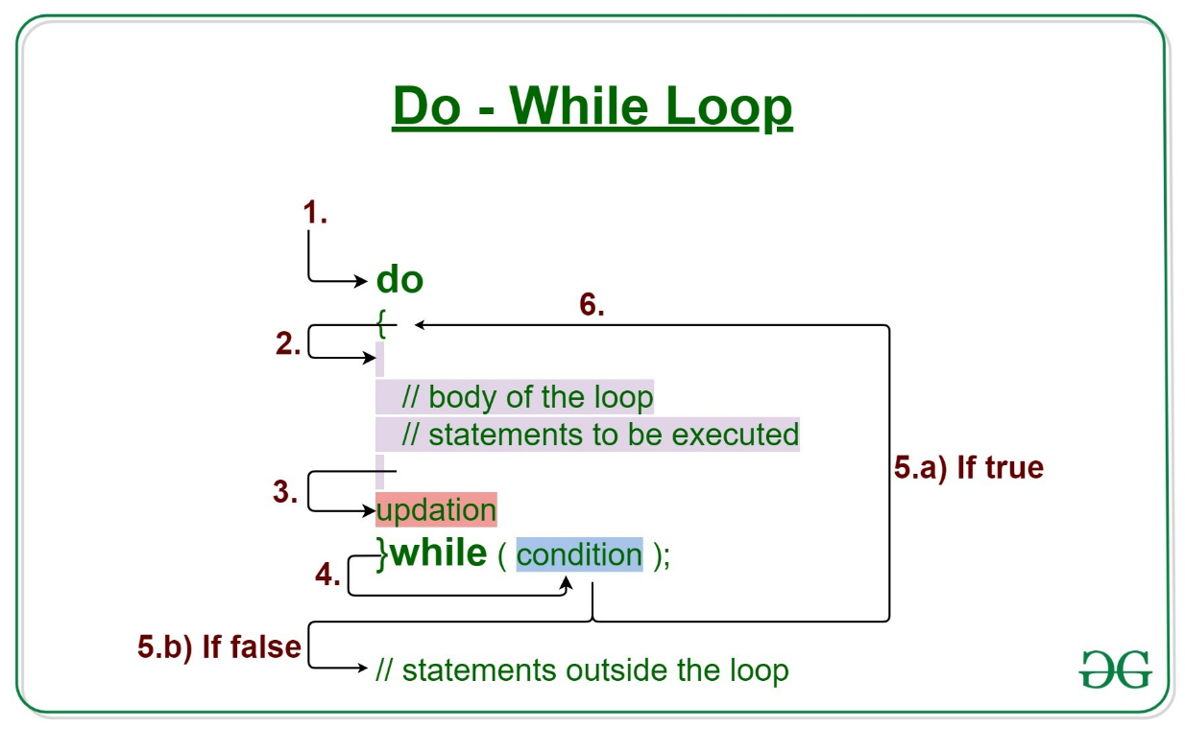

**Foreach Loops**

If we needed index we use for loops

Otherwise we use foreach loops